/Users/apple/Library/Containers/com.microsoft.Outlook/Data/Library/Caches/Signatures/signature_2105988401

**Professional Practice**

**40302211**

**L/618/7398**

**Section (4)**

**Group WORK**

**Submitted to**

Noura Alnashif.

**Submitted by**

**Amro Eltarsha**

**Ahmad Maghaireh**

**Obada Alhalaybeh**

**Ahmad Abu Alsamen**

**Spring –2024**

Contents

[Introduction 5](#_Introduction)

[The target audience 6](#_Toc166617218)

[Objectives and learning outcomes 6](#_Toc166617219)

[Teaching attendees leadership and how to communicate efficiently in a contingency and engaging in activities. 6](#_Toc166617220)

[Improving interpersonal skills through communicative and interactive sessions. 6](#_Toc166617221)

[Showing the way of continuous professional development. 6](#_Toc166617222)

[Creating a caring and a productive community at Beyond-The-Technical 2024. 6](#_Toc166617223)

[Engaging participants in immersive activities like "Escape the Room" to foster teamwork, problem-solving, and decision-making skills. 7](#_Toc166617224)

[Duncan Stevens 7](#_Toc166617225)

[Suresh Devnani 8](#_Toc166617226)

[Kevin Abdulrahman 9](#_Toc166617227)

[Jimmy AKA MR.Beast 10](#_Toc166617228)

[Agenda 10](#_Toc166617229)

[DAY 1: Teaching leadership and effective communication skills 10](#_Toc166617230)

[· Session one 10](#_Toc166617231)

[· Session two 11](#_Toc166617232)

[· Session three 11](#_Toc166617233)

[DAY 2: Inter-personal skills improvement 11](#_Toc166617234)

[· Session one 11](#_Toc166617235)

[· Session two 11](#_Toc166617236)

[DAY 3: continuous personal growth along with creating a successful community 11](#_Toc166617237)

[· Session one: 11](#_Toc166617238)

[· Session two: 12](#_Toc166617239)

[· Session Three: 12](#_Toc166617240)

[· Session four: 12](#_Toc166617241)

[Communication Matrix 12](#_Toc166617242)

[Professional schedule 16](#_Toc166617243)

[Contingencies Table 18](#_Toc166617244)

[Budget Summary 19](#_Toc166617245)

[Part two II 21](#_Toc166617246)

[INTRODUCTIONs 21](#_Toc166617247)

[Root Cause Analysis. 22](#_Toc166617248)

[GROW model. 23](#_Toc166617249)

[GROW stands for goal, Reality, Options, and Way Forward (specify actions). 23](#_Toc166617250)

[OODA 24](#_Toc166617251)

[OODA stands for observe, orient, decide, and act. 24](#_Toc166617252)

[PCDA 24](#_Toc166617253)

[PCDA stands for plan, do, check, act. 24](#_Toc166617254)

[Fishbone Diagram 25](#_Toc166617255)

[The 5-way technique 26](#_Toc166617256)

[Root Cause Analysis Application 27](#_Toc166617257)

[1-Define the problem 27](#_Toc166617258)

[2- Collect data 28](#_Toc166617259)

[3-Identify possible causes 29](#_Toc166617260)

[4-Identify the root cause 30](#_Toc166617261)

[Brain Storming before implanting the solutions 30](#_Toc166617262)

[5-Recommend and implement solutions 31](#_Toc166617263)

[Applied Methodologies 32](#_Toc166617264)

[• Waterfall Methodology: 32](#_Toc166617265)

[• Scrum Methodology: 33](#_Toc166617266)

[Agile Methodology: 33](#_Toc166617267)

[Identify the Purpose: 34](#_Toc166617268)

[Plan: 34](#_Toc166617269)

[Develop: 34](#_Toc166617270)

[Test: 34](#_Toc166617271)

[Deploy: 34](#_Toc166617272)

[Execution: 35](#_Toc166617273)

[Maintenance: 35](#_Toc166617274)

[Reference for part II 35](#_Toc166617275)

**Part l**

**Who we are?**

**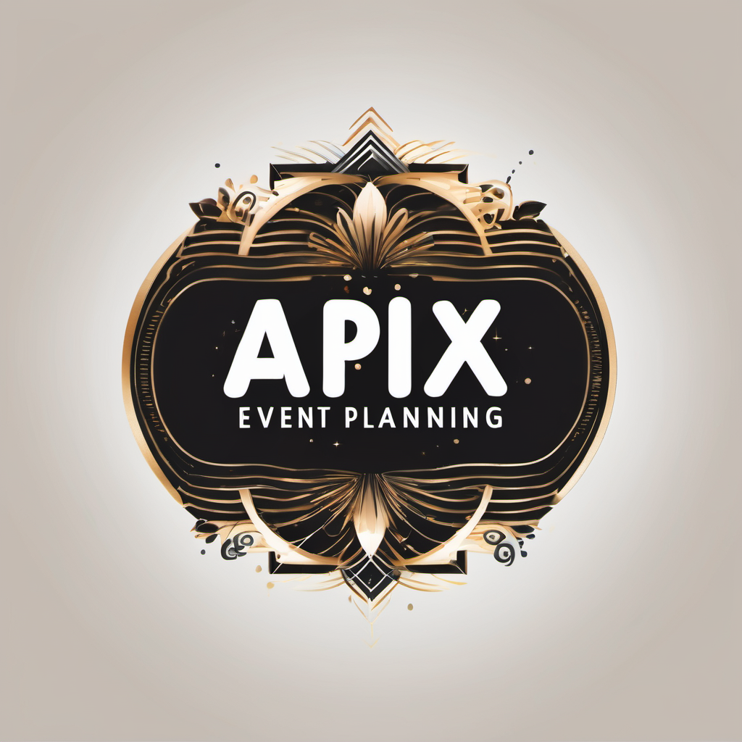**

**(1)**

Welcome to Apix Event Planning, where we create unforgettable experiences for your special moments. With a keen eye for detail and a love for creativity, we specialize in making events that reflect your style and personality. Whether it's a small gathering or a big celebration, we handle every part of your event with care.

Our team of experienced planners works closely with you to understand your vision and make it a reality. Whether you're planning a wedding, birthday party, or a corporate event, we're here to make your event memorable.

At Apix Event Planning, we believe that every little thing matters. From choosing the perfect venue to coordinating with vendors, we take care of everything so you can relax and enjoy your event. Let's make your next event extraordinary. Contact us today to start planning!

[ApixEventPlanning@contact.events.com](mailto:ApixEventPlanning@contact.events.com)

# Introduction

***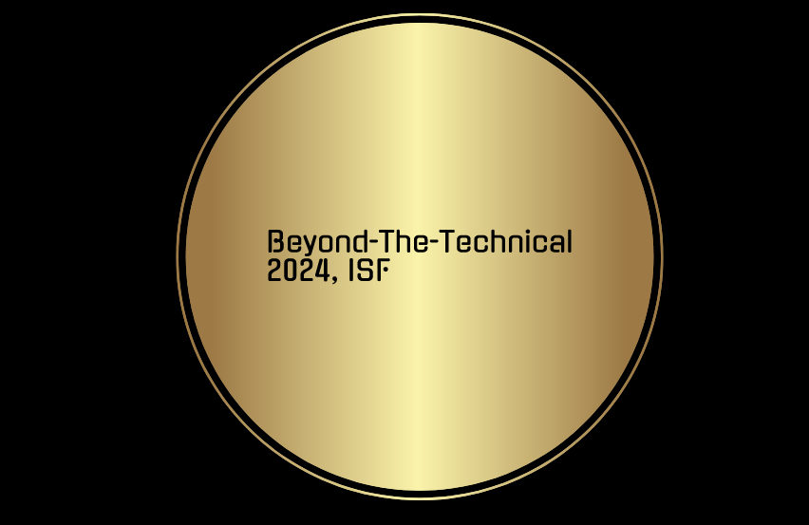***

***(2)***

Introducing to Beyond-The-Technical 2024, the annual event held by The International Space Foundation (ISF) which is dedicated to help engineers and IT professionals for the challenges and opportunities of tomorrow’s technological landscape. As we pursue this journey of knowledge, innovation, collaboration and sharing, we are delighted to invite you to join this informative experience.

In an era where technological advancements are rapidly spreading, the role of IT professionals and engineers has never been more fundamental, even though the main goal of (ISF) is to study space and its magnificence, it also plans on creating a better future which is why the Beyond-The-Technical event is a great event specified to grasp the fundamentals of interpersonal skills and to teach them to IT professionals and engineers from diverse backgrounds, and help them enhance their skills in critical areas beyond the technical view, which will be a three days plan to ensure covering topics such as: communication, problem solving and leadership in critical moments.

Our agenda aims to provide a great understanding of interpersonal skills; therefore, the trajectory of the event will contain interactive conversations, fun activities and quizzes to guarantee the operation succeeds no matter how different the backgrounds of the participants are, this event will provide the right assistance for you.

On behalf of (ISF) and the organizing team from Event Venture, we welcome you to join us at the extraordinary event Beyond-The-Technical 2024!

# The target audience

500 IT professionals and engineers from diverse backgrounds that are seeking to develop their interpersonal, problem solving and communications.

# Objectives and learning outcomes

## Teaching attendees leadership and how to communicate efficiently in a contingency and engaging in activities.

* The objective here is to help creating meaningful connections and collaborations in addition to teaching them leadership principals by professionals among people from different countries and cultures, and the approach used to teach these principles in via activities such as, chatting sessions together, doing quizzes and most importantly dividing them into teams and facing them with real world contingencies. The learning outcome is they will be able to accommodate how to deal with tough scenarios and how communication and leadership can make all the difference.

## Improving interpersonal skills through communicative and interactive sessions.

* The objective here is to give participants the tools they need to get them out of their comfort zone and let them experience numerous challenges. The learning outcome is that they will enhance a lot of needed skills such as: problem-solving, creativity and critical thinking so when they face a problem, they will be able to address the issue

and find a solution efficiently.

## Showing the way of continuous professional development.

* The objective here is to show the path of constant self-improvement by providing lifelong advices and tips that could potentially change their life forever which will keep them in a constant stage of skills and career enhancement. The learning outcome is that they will know the best practices of self-improvement and they will acquire a new set of skills which will allow them to expand their expertise.

## Creating a caring and a productive community at Beyond-The-Technical 2024.

* The objective here is to make an environment that’s caring, accepting, collaborative and most importantly productive that always gets the job done smoothly without any issues whatsoever where attendees can communicate, connect and share knowledge. The learning outcome is that the attendees will have the opportunity to make friends and connections as they will engage in discussions where they will meet new people with different experiences and they will learn from their experience.

## Engaging participants in immersive activities like "Escape the Room" to foster teamwork, problem-solving, and decision-making skills.

* The objective here is to make Participants apply and practice what they learned during the event in a fun way that will enhance their ability to collaborate under pressure, think critically, and solve complex problems as a team, leading to improved teamwork and decision-making in professional settings.

Event details

Title: Beyond-The-Technical 2024.

Duration: 3 days.

Date: 25h of Apr 2024

Location: Landmark Amman Hotel and Conference Centre.

***Keynote speakers.***

# **Duncan Stevens**

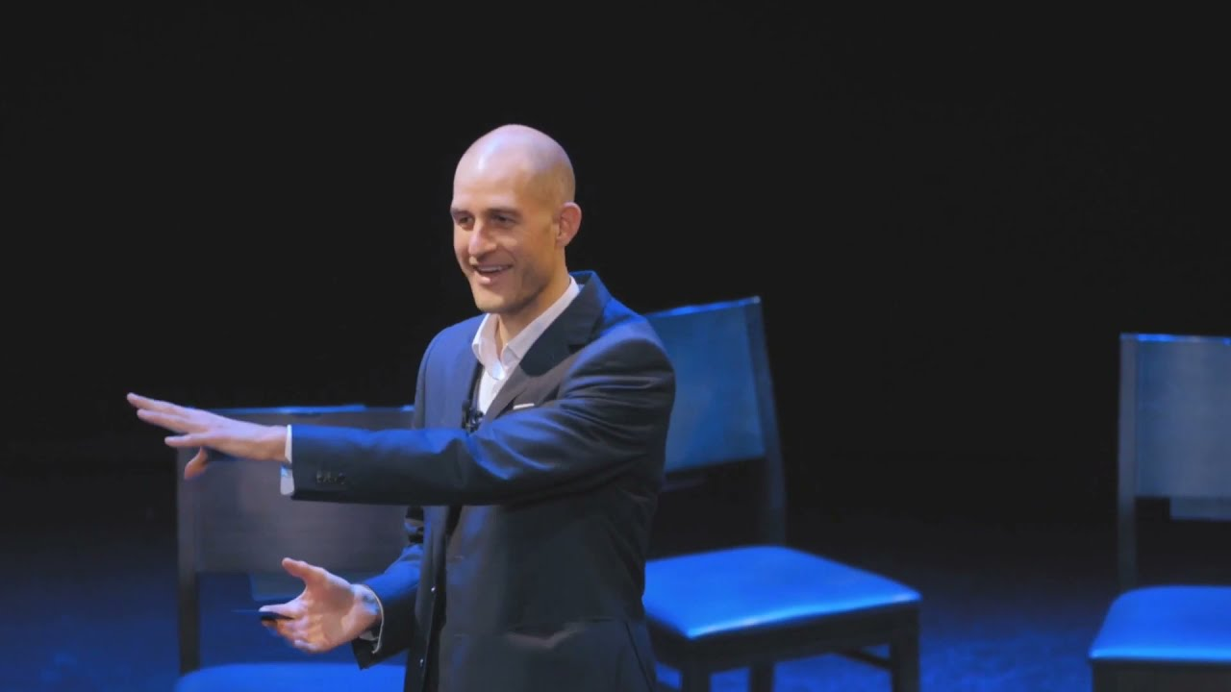

(3)

Top keynote speaker in Amman, Duncan Stevens is a world-leading expert in influence, persuasion, sales, leadership and change management. He delivers keynotes around in around Amman, Jordan and internationally from [Casablanca](https://duncanstevens.com/keynote-motivational-speaker-casablanca-morocco) to [Chennai](https://duncanstevens.com/motivational-keynote-speaker-chennai-india) and from [Chicago](https://duncanstevens.com/motivational-keynote-speaker-chicago-illinois) to [Cologne](https://duncanstevens.com/motivational-keynote-speaker-cologne-germany). His inspiring keynotes are entertaining, engaging and packed with content.

# Suresh Devnani

(4)

Jordan best motivational speaker Dr. Suresh Devnani is an International Keynote Speaker, Inspirational Speaker, Wellness Speaker, 4 x TEDx Speaker, Wellbeing Consultant, Future of Work Strategist, Leadership Keynote Speaker, Happiness Consultant and Coach, Best-Selling author of 4 books, Speaker on Happiness in Jordan and Global Conference speaker who shares practical strategies from his 28+ years of professional experience and his on-going global research in Leadership, Personal Growth and Organizational transformation. His mission is to inspire people globally on how to apply positive psychology to boost productivity, engagement, creativity, innovation and increase profits.

# Kevin Abdulrahman

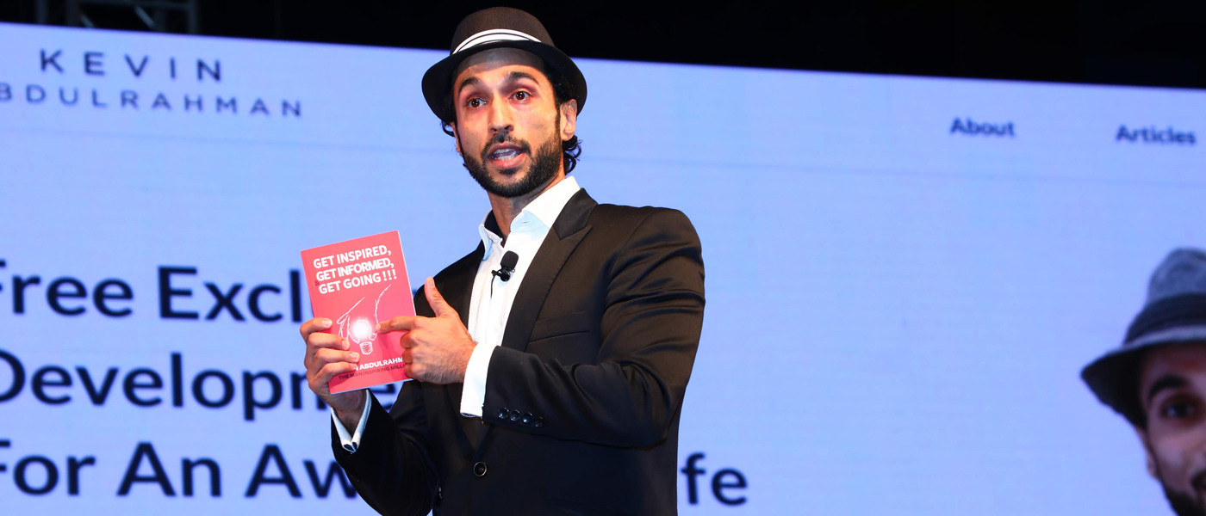

(5)  
Trusted by event planners worldwide, Kevin delivers engaging keynote speeches for events ranging from large conferences to small professional development gatherings. Kevin has spent decades developing an approach that includes customized content and personalized anecdotes to provide more than just a canned speech that is guaranteed to move his audiences. Kevin’s keynote speeches will offer you and your team topics for discussions and actionable and applicable takeaways for success.

# Jimmy AKA MR.Beast

**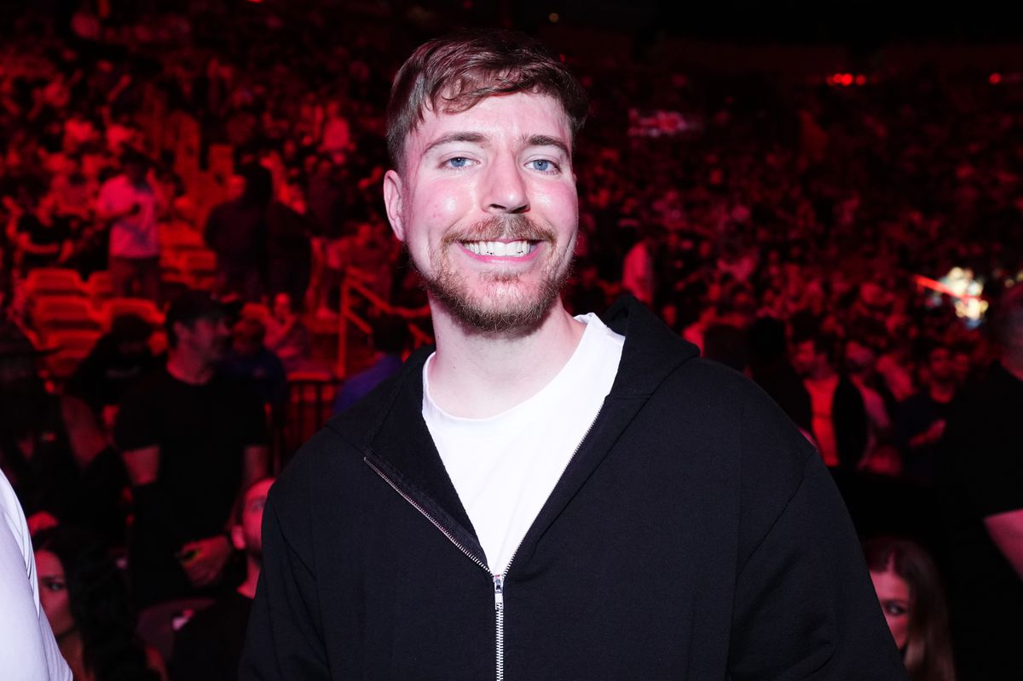**

**(6)**

Meet our speaker, Jimmy, also known as Mr. Beast, a YouTube sensation and philanthropist. With a passion for entertaining and helping others, Jimmy has captured the hearts of millions with his unique videos and generous acts. From epic challenges to life-changing giveaways, Jimmy's content inspires and entertains people of all ages. Join us as Jimmy shares his story and insights, leaving you inspired and motivated to make a difference.

# Agenda

## DAY 1: Teaching leadership and effective communication skills

* Session one: (10:00-2:00) Introduction.
* (10:00-11:30) arrival time and an introduction to the event explaining the plan and the agenda.
* (11:30-1:00) Starting the event with a communicative activity that helps the attendees get used to each other.
* (1:00-2:00) lunch in hotel open buffet
* Session two: (2:00-6:00) Teaching leadership principles.
* (2:00-3:00) A presentation by Duncan Stevens on the leadership principles needed in the real world.
* (3:00-4:00) Dividing participants into teams to face real-world contingencies.
* 30 minutes break.
* (4:30-6:00) Engaging in activities such as: group discussions about certain problems to stimulate task-managing.
* 1 hour break.
* Session three: (7:00-10:00) communication in crisis training
* (7:00-8:00) Doing exercises that are effective in dealing with challenging situation.
* (8:00-9:00) Randomly giving each one in every team a certain role to let them obtain adaptability no matter the task they are given in the future.
* (8:00-9:00) Dinner

## DAY 2: Inter-personal skills improvement

* Session one: Inter-personal skills challenges.
* (9:00-10:00) Breakfast
* (10:00-11:00) A presentation on the most important inter-personal skills presented by Suresh Devnani.
* (11:00:12:00) Group discussions on how to talk effectively.
* (12:00-12:30) Having everyone do an exam that is all about problem-solving and who can make the best decision in critical moments.
* 30 minutes break.
* (1:00-2:00) Swapping teams and making them have a group quiz so they can think together to come up with the best solution.
* (2:00-3:00) lunch in hotel buffet
* Session two: (3:00-6:00) creativity enhancing sessions.
* (3:00-4:00) A presentation on how to think outside the box, and how to think from different point of views that shows the better approach to different everyday problems.
* (4:00-6:00) Letting everyone discover his creativity by doing activities the require brain-storming sessions which will allow them to generate innovative ideas.
* (6:00-8:00) dinner in hotel buffet

## DAY 3: continuous personal growth along with creating a successful community

* Session one: (9:00-1:00) showing the path of personal development.
* (9:00-10:00) Breakfast in hotel buffet
* (10:00-11:00) A presentation by Suresh Devnani on how to be in a constant search for mistakes in yourself and how to evaluate it in order to become better.
* (11:00-1:00) Creating sessions that will make everyone obtain the critical skill of career planning, which will allow them to always know the next step after achieving their goals.
* (1:00-2:00) lunch in hotel buffet
* Session two: (2:00-4:30) creating a successful community that is productive.
* (2:00-3:00) Showing the successful way of true communication via sessions together which makes everyone capable of understanding his position and base his actions on it.
* (3:00-4:30) Allowing the attendees to share knowledge and experience, connect and make useful relationships that will help building a community that’s socially successful without sacrificing productivity.

* Session Three: (4:30-9:30) Enjoy a collaborative fun activity with Mr. Beast, the world's largest activities channel. Mr. Beast will generously sponsor his own activity during his allocated time, allowing participants to put into practice what they've learned earlier in the event.

* (4:30-5:00) Jimmy will kick off the session by introducing himself to the audience, followed by a clear explanation of the activity, which is "Escape the Room." He'll outline the roles and set up teams for maximum engagement and enjoyment.
* (5:00-9:00) kick off the activity and dive into an exhilarating session of playing the escape room game
* (9:00-9:30) Announcing the winning team, and giving the prizes

* Session four:(9:30-10:00) revising everything and thanking everyone for making it to Beyond-The-Technical 2024.
* Summarising day one, two and three, and evaluating every individual’s progression by doing one final quiz and a presentation by Kevin Abdulrahman.
* Providing general real-life tips that had happened in the past with evidence on their effectivity.
* Thanking everyone for making the time to attend the event and leaving a suggestion box where they can leave suggestions to make the event next year even more delightful.

(10:00-11:00) dinner in hotel open bofeh

By having this wonderful mixture of skills being taught in such a short period of time, all of the 500 IT professionals and engineers will have a set of skills that is mandatory to have in real workplaces, which will allow them to have a base that they can use and improve from in order to obtain better opportunities in life and to improve their career overall.

# Communication Matrix

|  |  |  |  |  |  |  |  |
| --- | --- | --- | --- | --- | --- | --- | --- |
| **STAKEHOLDER**  **Identify the key stakeholders involved in the project. Please include the following information about each stakeholder: name, role.** | **External or Internal Stakeholder** | **COMMUNICATION OBJECTIVES**  **Define the overall communication objectives for the project, including such goals as raising awareness, promoting engagement, providing updates, or gathering feedback.** | **RESPONSIBLE**  **PARTY**  **Indicate the person or team responsible for delivering each message. Doing this helps ensure accountability and clarity.** | **COMMUNICATION  METHODS**  **List the various communication channels that you will use to reach stakeholders. These channels can include email, newsletters, social media platforms, Face to Face, Screen to Screen, websites, meetings, workshops, or any other relevant medium.** | **FREQUENCY**  **Determine the frequency and timing of communication activities. Such activities can include providing regular updates, highlighting events, or disseminating any other time-sensitive information (As Needed, Once, Daily, Weekly, Bi-Weekly, Monthly**  **Bi-Monthly, quarterly, yearly).** | **TIMING**  **If Date or time required specify.** | **COMMENTS** |
| International space foundation: Funding the event. | internal | Providing the requirements for the event and contacting Event Venture to keep an eye on their progression and giving them feedback along the line. | Project manager | Email  Phone calls.  Virtual meetings  Meeting in real life | Bi-weekly | Every two Sundays | - |
| Event Venture company: organizing the event. | internal | Organizing the event while communicating with the (ISF) for additional details and giving them feedback regarding the event execution. | Project organizing team | Email  Phone calls  event website | weekly | Every Monday | - |
| IT professionals and engineers: attending the event to learn and improve. | external | Receive the event invitations and details about the event and give feedback. | Project event organizing team | Email  Social media | As needed | - | - |
| Guests and the advising team: sharing their knowledge amongst attendees. | external | Receive invitations and details about the event and a detailed explanation of the diversity of the audience to get an idea on how to deal with them. | Project service team | Email  Social media  Phone calls |  |  | - |
| Sponsors  (Mahmood Saeed Comapny-BoomBoom Drinks) | external | Receive constant details and updates about the visibility of the event and provide the sponsorship payment. | Sponsorship organizing team | Email  Phone calls  Their website | As needed | - | - |
| Media partners  (Roya) | external | Promote the event through media and offer the option to participate in the event virtually for a reasonable fee to support the budget of the event. | Media relations team | Email  Phone calls  Their website | As needed | - | - |
| Escape the room company.  (jimmy) | external | Creating the rooms and getting them ready to use | The company crew | Email  Phone calls  Virtual meetings | Every 2 weeks | - |  |

# Professional schedule

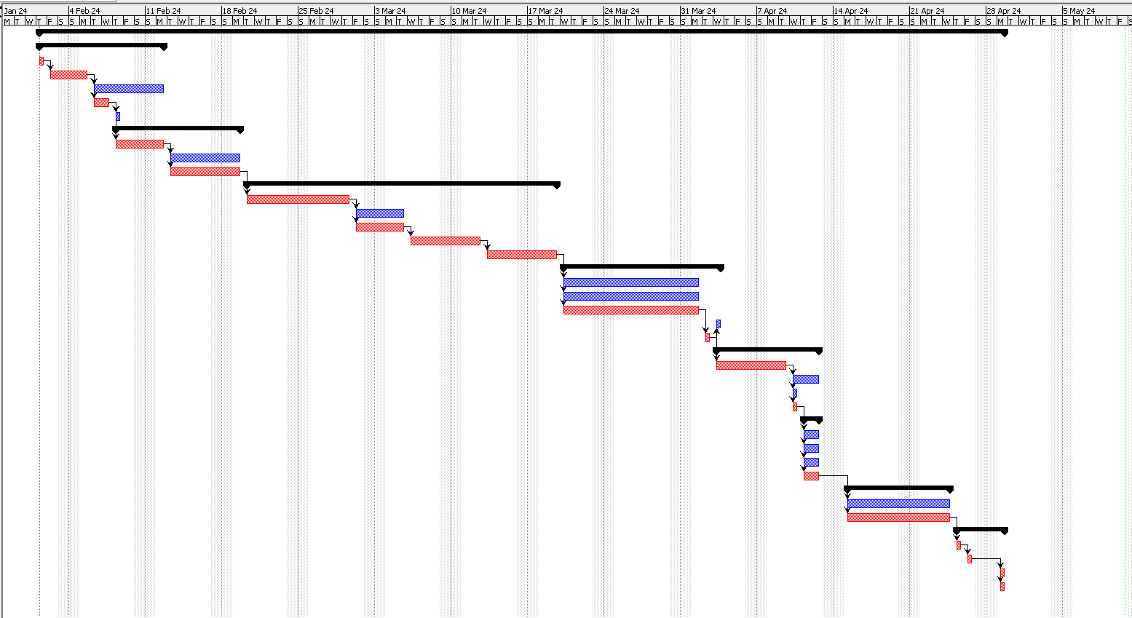

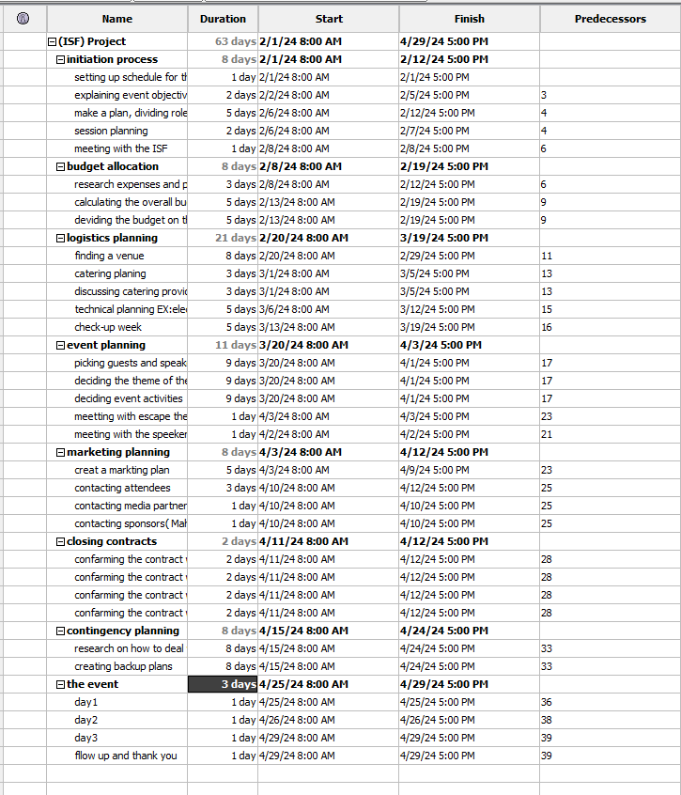

# Contingencies Table

|  |  |  |  |  |  |  |
| --- | --- | --- | --- | --- | --- | --- |
| Risk Category  (Logistical / Technical/ Personnel/ External/ etc.) | Expected occurrence time (Planning Phase or Execution) | Specific  Risk | Likelihood (Low / Medium/ High) | Impact (Low/ Medium/ High) | Preventive measures \* | Contingency Plan\*\* |
| logistical | planning | Venue double booking | medium | high | Regular checkups on the venue managements to make sure that the plan is still active | Immediately contacting an alternative within the extra time given for such contingency |
| technical | execution | Issues with the machines used | low | medium | Do regular testing the machines and have a set of backup machines. | Use the backup machines and if they’re also not working use an alternative way that doesn’t require a machine to get the job done |
| personnel | execution | The staff can’t make it to the event | low | high | Contacting them regularly | Having the attendees start with activities that doesn’t require the staff help until a new staff is hired |
| weather | execution | The weather gets really bad | low | low | Keeping an eye on weather news | Doing indoor activities first while the weather gets better |
| financial | planning | Unexpected additional cost to the event | medium | medium | Regular checkups on budget and always looking for cheaper alternatives | If it happens look into alternatives and contact stakeholders for financial discussions to address the problem |

# Budget Summary

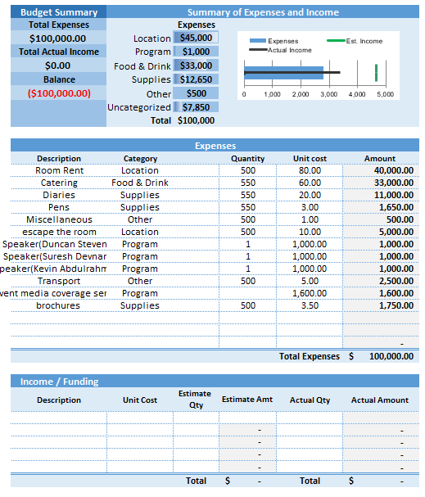

**Referenc part I**

**(3)** A-speakers. (n.d.). *Duncan Stevens*. [online] Available at: https://www.a-speakers.com/speakers/duncan-stevens/ [Accessed 1 May 2024].

‌

**(4)** omny.fm. (n.d.). *In-Conversation with Motivational Speaker Dr. Suresh Devnani - Dubai Eye 103.8*. [online] Available at: https://omny.fm/shows/dubai-eye/in-conversation-with-motivational-speaker-doctor-d [Accessed 11May 2024].

‌

**(5** SPEAKING.com Keynote Speakers Bureau. (n.d.). *Kevin Abdulrahman | Speaker Agency, Speaking Fee, Videos*. [online] Available at: <https://speaking.com/speakers/kevin-abdulrahman/>.<https://speaking.com/speakers/kevin-abdulrahman/>. [Accessed 11May 2024].

‌(6) Diaz, A. (2024). *MrBeast’s latest stunt? Making the ‘greatest show possible’ with Amazon*. [online] Polygon. Available at: <https://www.polygon.com/24105203/mrbeast-amazon-show-beast-games-squid-game-streaming-youtube> [Accessed 11 May 2024].

‌

# Part **two II**

## INTRODUCTIONs

Planning a three-day training program for ISF may encounter some challenges. Unforeseen expenses or financial constraints could disrupt the planning process, potentially compromising the quality of the experience and services offered. Additionally, last-minute changes in venue availability or facility-related issues may pose difficulties in finding a suitable location. Coordinating participant accommodations, travel arrangements, and other logistics could also prove challenging, impacting the overall attendee experience. Furthermore, managing the busy schedules of speakers, instructors, and participants may present scheduling challenges, potentially affecting the planned events. Finally, unforeseen errors in computer systems or data presentation could lead to delays and chaos in the schedule. The success of this event will depend on how effectively we address these potential challenges in practical application.

The Main problem we encountered was the budget shortage, so analyses the situation and came up with the ideal form of it.

Considering our budget limitations, our ideal situation for the event is to meticulously plan and execute it, creatively optimizing resources to maintain a high-quality experience despite the 30% budget reduction. By effectively engaging our audience, ensuring top-notch speakers, and implementing engaging and memorable activities, we can still deliver an exceptional event experience within our financial constraints. This approach aligns with our objectives and ensures a successful event that creates a lasting positive impression and garners positive attendee feedback

Due to unforeseen circumstances, we are facing a 30% reduction in our budget for the event, which is impacting our ability to deliver the same level of quality and experience that we originally envisioned.

the size and scope of the problem: The 30% budget reduction equates to a significant decrease in our financial resources, limiting our ability to secure top-tier venues, entertainment, and other crucial elements that contribute to the overall success of the event. This reduction also affects our marketing and promotional efforts, potentially impacting attendance and overall engagement.

Given the 30% budget reduction, we're facing significant limitations in securing top-tier venues, entertainment, and other crucial elements that contribute to the event's success for example:

Budget limitations can profoundly impact events by restricting venue choices, reducing the scale and production quality, limiting entertainment options, hindering technological innovation, compromising logistical support, diminishing sponsorship opportunities, and impeding risk management. These constraints force organizers to make difficult decisions,

potentially leading to compromises in attendee experience, overall professionalism, and event competitiveness also not achieving the expected event outcomes and objectives.

**Event planning requires effective problem-solving skills to address various challenges that may arise before, and during an event thus we need to have a way to solve these problems and there are some common techniques in problem solving we will delve into.**

* **First technique: Root Cause Analysis (RCA).**
* **Second technique: GROW model.**
* **Third technique: OODA loop.**
* **Fourth: technique: PDCA.**
* **fifth technique: cause and Effect Diagram (Fishbone diagram).**
* **sixth technique: the 5 Why Technique.**

# Root Cause Analysis.

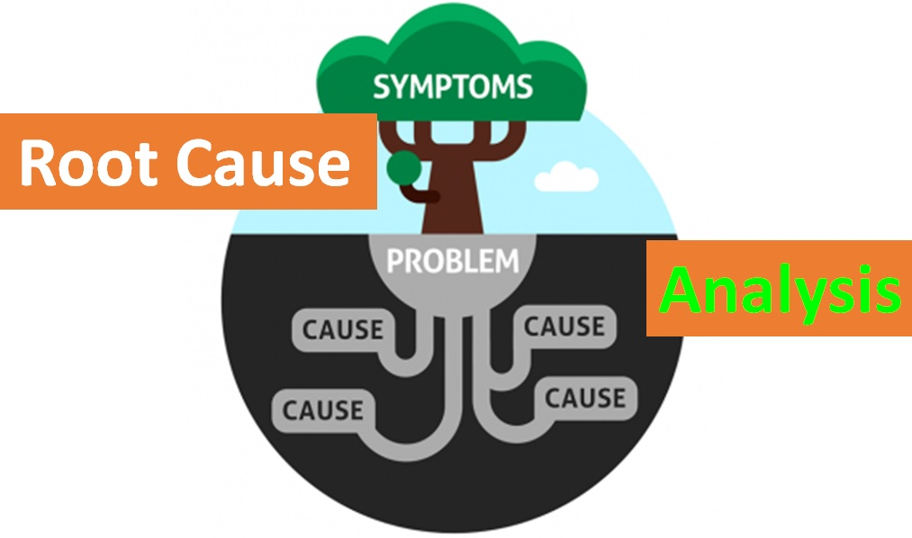**We use this technique usually to identify the root of a problem as we attempt to correct the cause or just eliminate it, we can shape it as a tree if the leaves show symptoms of illness we start looking for the problem and usually the roots of the tree could be the problem so we either try to fix it or remove it, this also apply to real life problems .**

**(1)**

‌

# GROW model.

## GROW stands for goal, Reality, Options, and Way Forward (specify actions).

**In this technique we first set a goal will be something achievable and can be solved, Then we at the reality we look at what is standing in our way and what constraint us finally we make a list with these problems , now we look at the options we have and try to find the best opportunities, allies, and the way we approach the problem, the way forward is more like the execution of the solution as we ask ourselves if we can improv it or take** another option that may be better for the long run.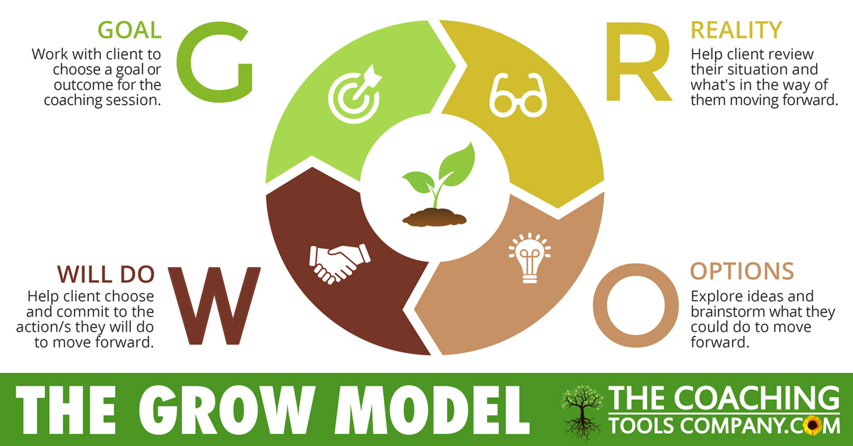

‌(2)

# OODA

## OODA stands for observe, orient, decide, and act.

**This technique is very simple, consisting, and reliable, this technique also run as a loop for the entire time of the planning.**

**Observe is to gather as much information as possible from wide verity of sources and to be as realistic as possible.**

**Orient is to analyse the information and to give frequent update if you are on the track.**

**Or running late.**

**Decide is to set your sight at the best plan to start with it.**

**Act is to start doing the changes that is needed to be done to solve the problem you have.**

****

‌(3)

# PCDA

## PCDA stands for plan, do, check, act.

**In the planning phase we start by defining the problem and understanding the facts, then we find the root of the problem after that we try to solve it and contain it.**

**Do we start doing the strategy from the planning phase.**

**Check in this stage we will be already done the solution, but we need to check if it did work as intended.**

**Act here is different from the OODA as it means to implement the new way of working to support what we progressed in and to get feedback.**

****

‌(4)

# Fishbone Diagram

**On this technique we first identify the problem then we split this problem into smaller categories of possible causes then we take every cause and look into it and try to identify the problem inside it , even though this is a good way to identify the problem it will not solve at as you need to take the right choice to solve that problem effectively ,and this will take a shape like a fish this is why it’s called that .**

**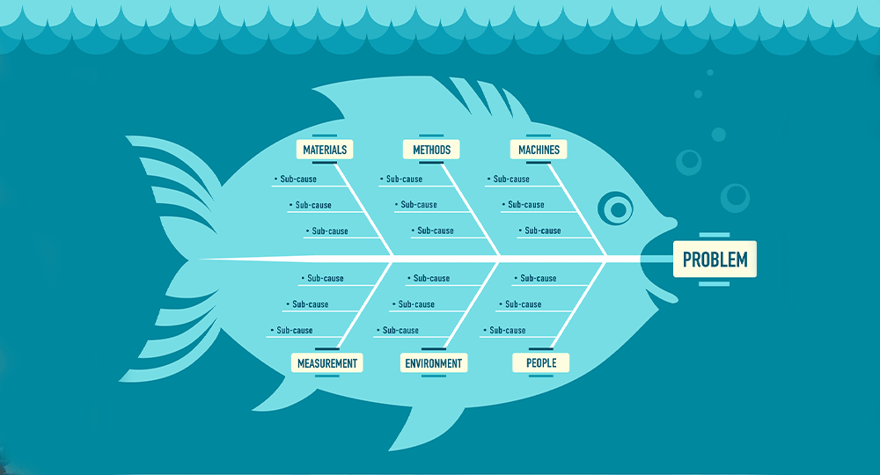**

**(5)**

# The 5-way technique

**it is a simple technique for problem-solving to reach the roots of the problem, it works by asking why on every step through the problem to get to the bedrock of it, we start by asking why the problem occurred? then we ask why for the answer and so on until we find the solution and prevent it from happening in the future.**

**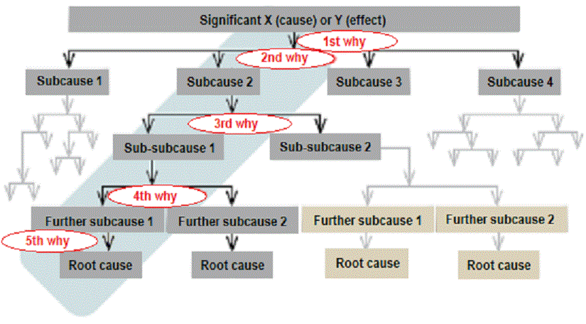**

(6)‌

# Root Cause Analysis Application

# 1-Define the problem

Our current problem arises from a failure to stick to our budget, resulting in a significant overspend of 30% for the event. This financial misstep has generated a series of symptoms that are now impacting various stakeholders and the overall success of our event.

Financial instability, caused by budget overruns, has introduced stress and uncertainty among stakeholders such as employees, investors, and creditors. This deviation from our financial plan has led to a reduction in our ability to make optimal choices. With a diminished budget, we find ourselves constrained in our options for venues and services, limiting our capacity to deliver the experience we aimed for.

Moreover, the strain on resources and the perceived mismanagement of funds not only affects the event but also affects trust and credibility in our organization's ability to execute projects effectively. This loss of confidence can have far-reaching consequences, impacting our relationships with stakeholders and potentially make future plan hard to succeed.

# 2- Collect data

We see that after some research we came to the conclusion that the budget was incorrect from different aspects, as this budget was made before looking deeply on the prices of the logistics and reservations and this show how we are down 30% from what is the real budget.

This problem was found when the execution of the initial steps began for example when we contacted the venue they gave us a price but when we went to confirm they told us the prices went up since others offered more and it is on a busy month, and the impact of this would be catastrophic for us as a team and a company and will lower our trust rate in the market since the event will be cancelled if we do not recover from this event.

# 3-Identify possible causes

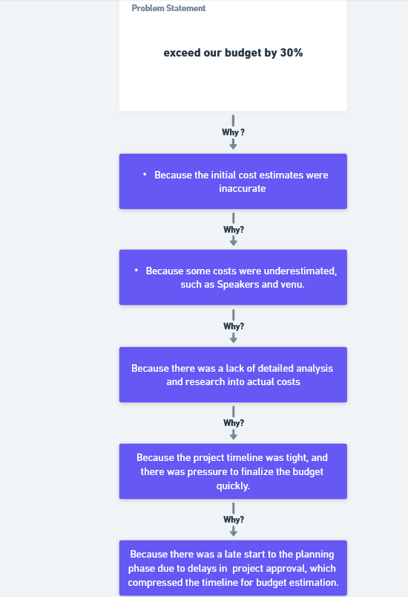

# 4-Identify the root cause

**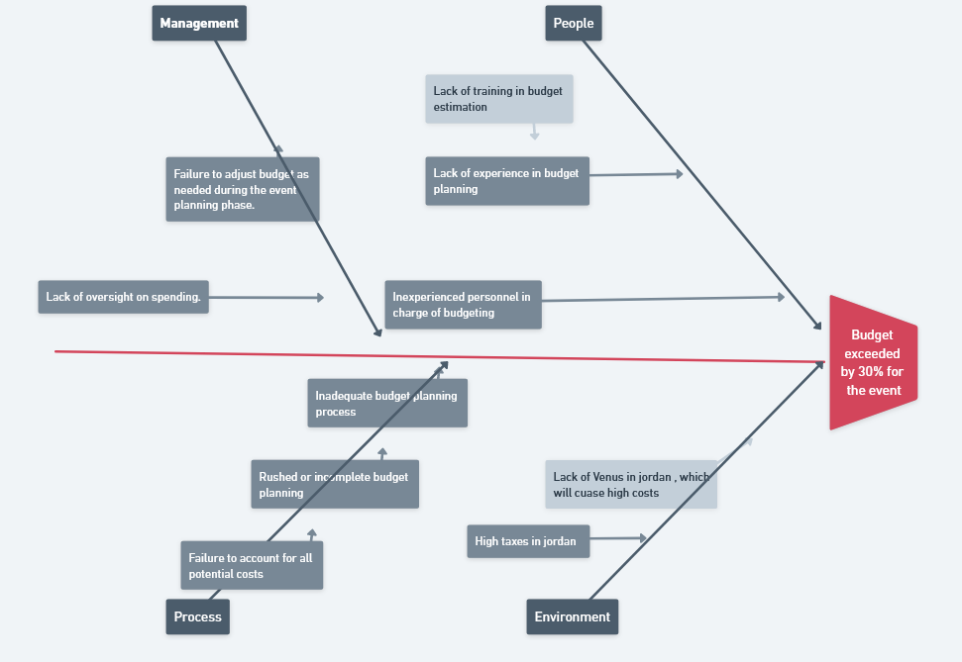**

# Brain Storming before implanting the solutions

To tackle the budget issue, we gathered and brainstormed together, pooling all possible ideas, ranging from logical to the more creative. Everyone had a chance to contribute, discuss, and refine each suggestion. Through this collaborative effort, we generated multiple ideas that evolved and combined into two main concepts:

Ahmad Abu Alsamen suggested to arrange double beds in the room for attendees: Instead of the typical single bed setup, we proposed placing two beds in each room to accommodate more attendees comfortably. This not only maximizes space utilization but also fosters a more communal atmosphere among participants, along with reducing the budget.

Another great solution was Obada’s which was to negotiate with vendors in order to get discount while offering them a partnership in the future, and this solution not only helps with the current financial contingency but also provides a possibility to work and stay in business in the future.

Hosting the event in the desert was Amr’s idea : A bold yet intriguing idea emerged to shift the location of the event to the desert. This unconventional setting offers unique opportunities for experiences and engagements, potentially reducing costs associated with venue rental and amenities.

Creating small shops that sell souvenirs and snacks was Ahmad’s idea: another fantastic idea! Consider opening a small bazaar shop or mini market that offers souvenirs relevant to the local area and any ongoing events. The revenue generated from souvenir sales can directly contribute to addressing our budgetary challenges.

We used group passing techniques, everyone suggested one idea then we passed the ideas to each other to Critique it and make small improvement one each idea.

|  |  |  |  |  |  |  |  |  |
| --- | --- | --- | --- | --- | --- | --- | --- | --- |
|  | Evaluation Matrix For Decision Making | | | | | | | |
|  | | A | B | C | D | Row Sum | Rank | |
| A: Maximizing Space Efficiency: Two Beds in One Room Strategy | |  | 1 | 0 | 1 | 2 | Second | |
| B: negotiation with vendors | | 0 |  | 0 | 1 | 1 | Third | |
| C: moving the location to wadi rum | | 1 | 1 |  | 1 | 3 | First | |
| D: small shop | | 0 | 0 | 0 |  | 0 | fourth |

# 5-Recommend and implement solutions

Such contingency requires creativity and innovation, so after analysing the problem and having brainstorming sessions, the team thought of a great solution which is changing the whole venue without compromising the learning outcomes and the experience by holding the event in Wadi Rum in the vast desert that will give each attendee the clarity for learning and it will not only maintain the quality of the event it will cost 25% of the original cost and allow us to provide more activities to ensure the educational experience, the great feature about this place is that it is very easy to deal with especially with transportation where we will arrange busses and vans to take the attendees from the capital, and the venue can be made in a primitive style in the desert in tents, which will originate the experience and facilitate communication. The event will run the same way as the initial plan. So, to implement successfully we sent a team responsible of researching how to implement the event in Wadi Rum, and they found out that the fee per person costs five Jds which is significantly less than renting the hotel, so the cost is significantly decreased. They also researched the cost of tents and the needed equipment to run the event smoothly. And they gave a report that describes how the event will be much cheaper like this doesn’t sacrifice the experience but actually improves it by inspiring the attendees by the extraordinary nature in Wadi Rum as it will help them bond fast and create memorable experiences, but they also mentioned in the report that there are some risks in the taking this step such as: weather (hot days with cold nights) so a solution to that problem is to tell the attendees the importance of bringing appropriate clothes beforehand, also there will be minimal electricity so everyone should bring their own power bank. We are proud to say that our team researched enough to ensure that most contingencies are covered even the medical emergencies where there is a plan for whoever can’t continue the event. So, as you can see this way it is not only about learning, but also about enjoying nature while connecting to each other.

# Applied Methodologies

For an event planning company, the best methodology would depend on the nature of the event , the size of the team, and the level of flexibility required. Here's an overview of the three most used methodologies in companies :

# · **Waterfall Methodology**:

When discussing the Waterfall methodology, we found out some advantages and disadvantages. Firstly, the advantages of this methodology arise from its clear structure for planning and executing an event or project where there is less back and forth with customizations or while developing customizations. This methodology works perfectly with large projects with clear outcomes, such as building housing units or a rail system, where timelines and costs are easily predictable due to the clarity of the Waterfall methodology.

On the other hand, there are some disadvantages. The lack of flexibility is one, where customization goes against the falling direction of the water, as I like to describe it. Additionally, stakeholders and clients have less involvement in the project. In some projects, this can cause issues. For example, when making software using Waterfall, which is a big mistake by the one who chooses the methodology, a year later new technologies are released or new trends and customer needs arise. This can make your software great, but a year earlier, it may be outdated

.

When applying the Waterfall methodology to event planning, the process is typically divided into four primary phases:

1. **Gather Requirements**: Collect all necessary information and requirements for the event from clients or stakeholders.
2. **Design**: Develop a comprehensive event plan based on the gathered requirements, including the agenda, session topics, speaker lineup, logistical arrangements, and marketing strategy.
3. **Implement**: Execute the plans devised in the design phase, coordinating with vendors, managing event logistics, overseeing venue setup, and ensuring smooth operations during the event.
4. **Testing and Maintenance**: Conduct any necessary testing or adjustments during the event to ensure everything runs smoothly and address any issues that may arise

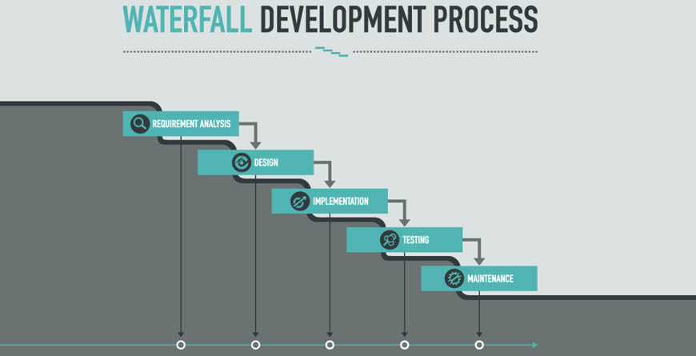

**(7)**

# • Scrum Methodology:

When discussing the Scrum methodology, we find both advantages and disadvantages.

Advantages: Scrum is a flexible approach that allows for iterative development, which can be beneficial for event planning where requirements may evolve. It promotes collaboration and communication among team members, leading to better outcomes. Additionally, Scrum allows for quick adaptation to changes, making it suitable for dynamic event environments.

Disadvantages: Scrum can be challenging to implement and manage, especially for teams unfamiliar with the methodology. It requires a high level of discipline and commitment from team members. Additionally, Scrum may not be suitable for all types of events, especially those with strict timelines and budgets.

When applying the Scrum methodology to event planning, the process is divided into several phases:

1. **Product Backlog Creation**: Create a list of all tasks and requirements for the event, such as booking artists, securing sponsors, and marketing the event.
2. **Sprint Planning**: Select tasks from the product backlog to work on during a fixed time period (usually 2-4 weeks) and create a sprint backlog.
3. **Daily Standups**: Hold daily meetings to discuss progress, obstacles, and plans for the day, keeping the team aligned.
4. **Sprint Review**: Demonstrate completed work to stakeholders, gather feedback, and make adjustments to the project plan.
5. **Sprint Retrospective**: Reflect on the sprint, identify areas for improvement, and continuously improve processes and performance over time.

Overall, Scrum can be beneficial for event planning, especially for events requiring flexibility and collaboration. However, it may need adaptation to suit specific event and team needs.

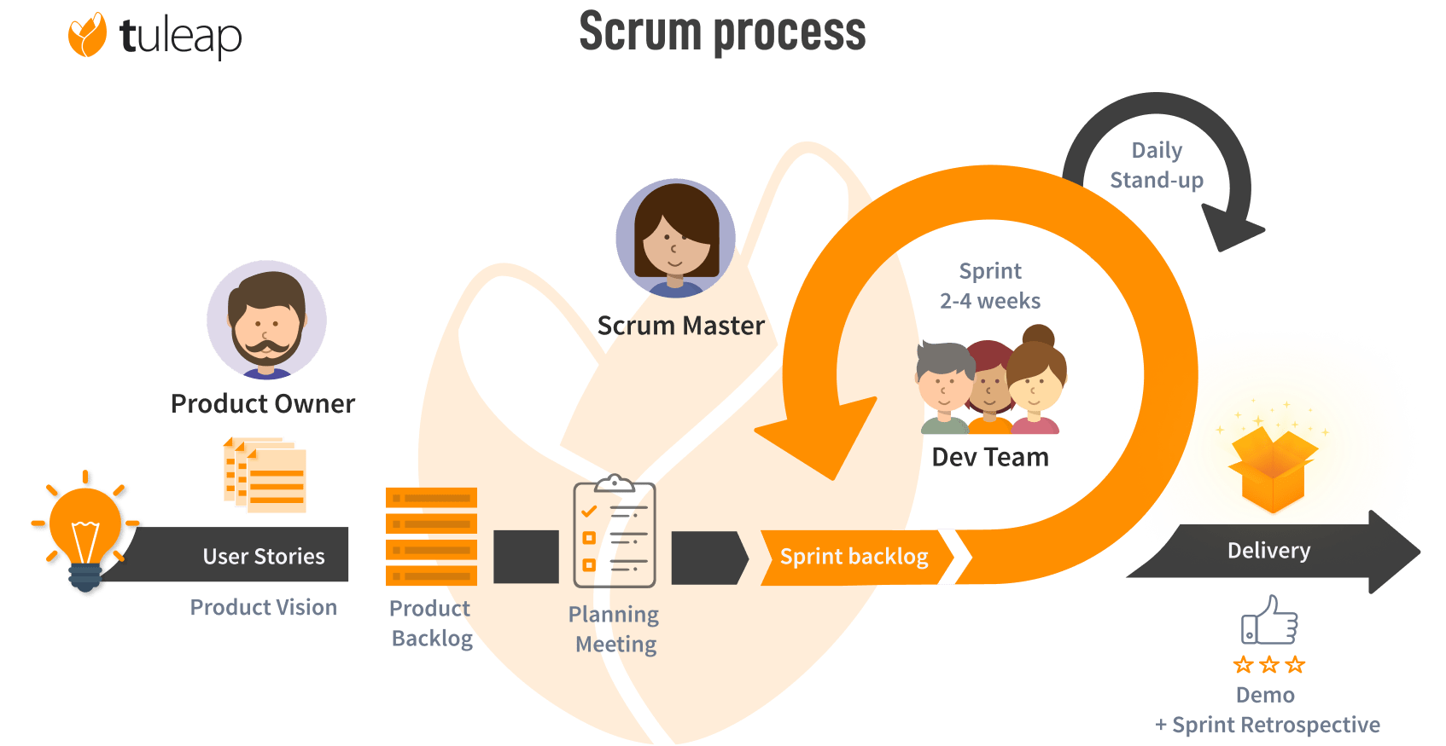

(8)

# Agile Methodology:

When discussing the Agile methodology, we find both advantages and disadvantages. The primary strength of Agile lies in its flexibility and adaptability, making it well-suited for projects or events with evolving requirements or where frequent changes are expected. Agile allows for iterative development, enabling teams to deliver a minimum viable product (MVP) quickly and then iteratively improve upon it based on feedback. This methodology also promotes greater collaboration and communication among team members and stakeholders, leading to better outcomes.

However, there are also challenges associated with Agile. Its emphasis on flexibility can sometimes lead to scope creep or difficulties in managing project timelines and budgets. Additionally, Agile requires a high level of involvement and commitment from all team members, which can be challenging to maintain, especially in larger teams or organizations, also the need for a significant investment in training and implementation, where in some cases there is no time or budget for that

While we were comparing the three methodologies we took into account all the advantages and disadvantages of every methodology, the most suitable one for our needs is agile, we mentioned above how agile can play a vital role in the success of the event also the flexibility and keeping thing up to date for every team member makes it the best choice

we overcame the disadvantages and challenges of agile, the most challenging one was the need for a significant investment in training and implementation, setting up a meeting with our time to explain the agile methodology

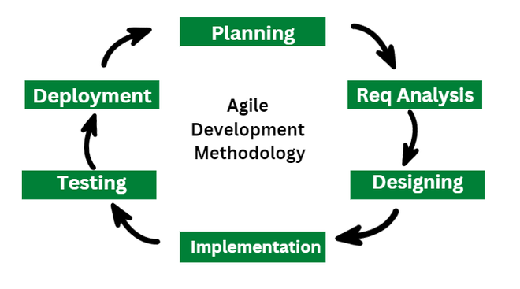

(9)

using the help of an expert in the professional practice field was an ice-breaking journey to every one of us when the team leader planned a meeting with Ms. Noura Al-Nashef, where we fully understand the agile methodology and how we implement it to our event

Applying the Agile methodology to event planning involves breaking down the planning and execution process into smaller, manageable chunks called "sprints." Each sprint typically lasts 1-4 weeks and focuses on delivering a specific set of tasks or objectives. The process is iterative, with regular review meetings to assess progress and make adjustments as needed.

## Identify the Purpose:

* Goal: Organize a training event for IT professionals and engineers focusing on interpersonal skills, leadership, and communication.
* Target Audience: 500 IT professionals and engineers seeking skill development.

## Plan:

* Agenda: Develop a detailed schedule for the event, including session topics and speakers.
* Logistics: Arrange for venue, equipment, catering, and accommodations.
* Budget: Create a budget plan detailing expenses and revenue projections.

## Develop:

* Divide the planning into sprints, with each sprint focusing on specific aspects like agenda creation, speaker outreach, and logistical arrangements.
* Assign tasks to team members based on their expertise and availability.

## Test:

* Conduct regular reviews to assess progress and identify any issues or delays.
* Use feedback from team members and stakeholders to make necessary adjustments.

## Deploy:

* Execute the plans for the event, including setting up the venue, managing registrations, and coordinating with speakers and vendors.
* Ensure that all logistical arrangements are in place for a smooth event.

## Execution:

* Implement the event plan, ensuring that all sessions run according to schedule and that attendees are engaged and informed.
* Address any issues or concerns that arise during the event promptly.

## Maintenance:

* After the event, conduct a post-event review to evaluate its success and gather feedback from attendees.
* Use this feedback to improve future events and refine the event planning process.

# Reference for part II

**(1)** Kooijmans, K.A. & R. (2017). *How Root Cause Analysis is done*. [online] Food Safety Experts. Available at: <https://www.foodsafety-experts.com/powerful-root-cause-analysis/> [Accessed 5 May 2024].

**(2)** Louise, E. (2020). *The GROW Model Explained for Coaches (Plus Special Report .PDF) | the Launchpad - the Coaching Tools Company Blog*. [online] The Coaching Tools Company. Available at: <https://www.thecoachingtoolscompany.com/the-grow-model-explained-for-coaches-questions-tips-more/>[Accessed 5 May 2024].

(3) www.linkedin.com. (n.d.). *Using the OODA Loop to Improve Decision Making in the Chaotic and Uncertain Cyberwar Environment*. [online] Available at: <https://www.linkedin.com/pulse/using-ooda-loop-improve-decision-making-chaotic-uncertain-kittle> [Accessed 5 May 2024].

(4) online.visual-paradigm.com. (n.d.). *4-Steps PDCA Method | PDCA Models Template*. [online] Available at: <https://online.visual-paradigm.com/infoart/templates/pdcamodel/4-steps-pdca-method/> [Accessed 5 May 2024].

(5) Lean Manufacturing Junction. (2024). *Types of Fishbone Diagrams*. [online] Available at: <https://lean-manufacturing-junction.com/2024/03/types-of-fishbone-diagrams/> [Accessed 5 May 2024].

‌

(6) asq.org. (n.d.). *Five Whys and Five Hows | ASQ*. [online] Available at: <https://asq.org/quality-resources/five-whys> [Accessed 5 May 2024].

**(7)** www.mindsmapped.com. (n.d.). *You are being redirected...* [online] Available at: <https://www.mindsmapped.com/waterfall-methodology/> [Accessed 5 May 2024].

‌(8) Tuleap. (n.d.). *Understanding Agile Scrum in 10 minutes • Tuleap*. [online] Available at: <https://www.tuleap.org/agile/agile-scrum-in-10-minutes> [Accessed 5 May 2024].

‌

(9) GeeksforGeeks. (2023). *What is Agile Methodology?* [online] Available at: <https://www.geeksforgeeks.org/what-is-agile-methodology/> [Accessed 5 May 2024].

‌